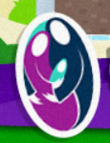  Forest School | Holy Family Reception Class & Playgroup / Forest School Plan
Learning Objective: Holistic exploration of pumpkins
LI: To compare pumpkins – their size and weight by practically holding them through play.
LI: To discover the properties of a pumpkin by rolling them, cutting them open, carving them.
LI: to celebrate Halloween by decorating a pumpkin for our pumpkin party, using real tools such as hammer and nails.
Success Criteria: Children to lift them, roll them, carry them, transport them in wheel barrows, bury them, wash them, throw them, examine them, smell them, kick them, scoop them out, paint them, compare them, count them, hammer them and decorate them, compare pumpkins – their size and weight by practically holding them through play. To discover the properties of a pumpkin by rolling them, cutting them open. To celebrate Halloween by decorating a pumpkin for our pumpkin party, using real tools such as hammer and nails.
Previous knowledge: unknown |  |  | Key words, concepts:  carve, paint, decorate, roll, carry, weight, heavy, light, small, large, compare, Pumpkins (variety of sizes)  Paint, Creative items ie. feathers, sticks, nails, a turnip  wheelbarrows and other modes of transport for the pumpkins
Session outline:
Warm Up: Children to assemble at the front of the school to carry pumpkins to Happy Hill.
Introduction: Children to listen to story ‘The Enormous Turnip.’
Activity: Children to decorate pumpkins for Halloween party.
Main Focus: Holistic exploration of pumpkin throughout the week.
Free Exploration: wash, paint, roll, count, compare, contrast pumpkins.
Plenary: Display and celebrate decorated pumpkins.
Key health and safety points:
Wet / hot weather option: Use indoor classroom
Session Evaluation: See attached.
Outcomes met |  | / |  | Behaviour / engagement | / | Timing / pace | /
Observations:
See attached photos

Key learning / development for children & leaders:
What went well?: Excellent participation
What did not go well?: Perhaps some activities e.g. rolling pumpkins down the hill could be teaching the children to disrespect food?
Ideas for next session:
Plant pumpkins in polytunnel in spring time.

Evaluation
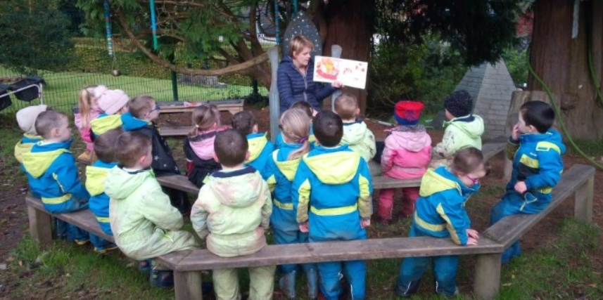
Story: The Enormous Turnip
The children looked at the turnip and compared it to the pumpkins. We discussed how difficult it is to carve a turnip and how much easier it is to carve a pumpkin. Briefly discussed how people used to carve turnips and then when the Irish people went to America they changed to carving pumpkins.
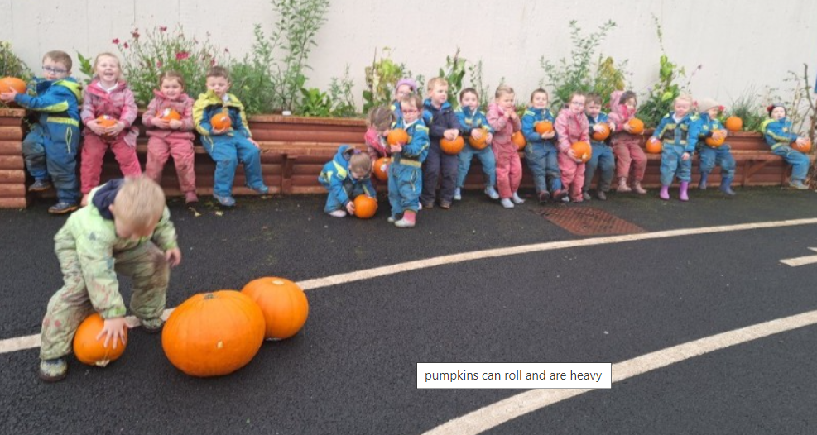
The children collected the pumpkins from the front of the school and had the difficult task of transporting them
up Happy Hill. They all wanted the large pumpkins at first. The children soon realised that the largest pumpkins
were the hardest to transport.
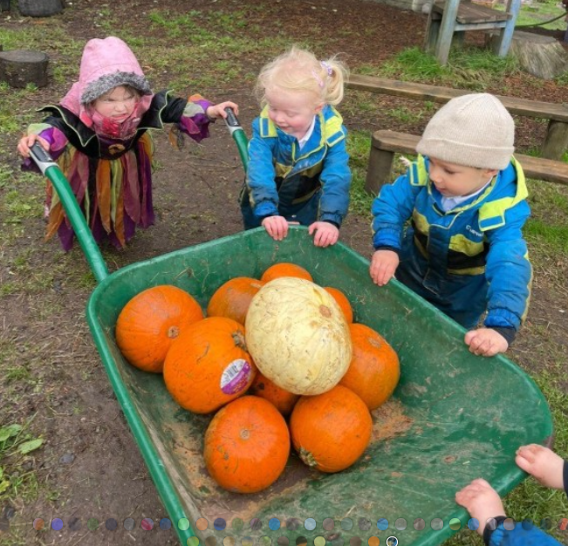  The children lift them, roll them, carry them, transport them in wheel barrows, bury them, wash them, throw them, examine them, smell them, kick them, scoop them out, paint them, compare them, count them, hammer them and decorate them! |  | 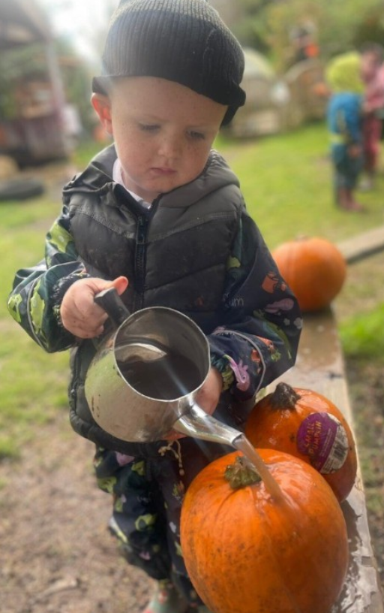  The children were given time and space to look closely at the pumpkins.
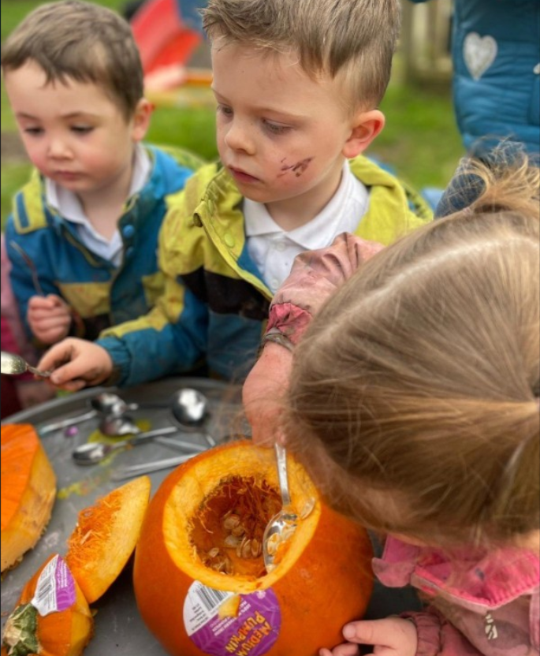
An adult removed the top of the pumpkin and the children scooped out the centre. Some children needed support so we would loosen up the centre and make it a little easier for them. However, we encouraged the children to keep going and to continue to scoop out – so all children built on their resilience and achieved! We discussed the smell of the inside of the pumpkin. We left one pumpkin to decompose and the children were able to see the decaying process as the pumpkin became all mushy and smelly
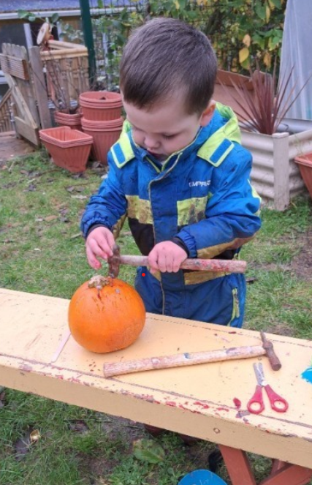 | 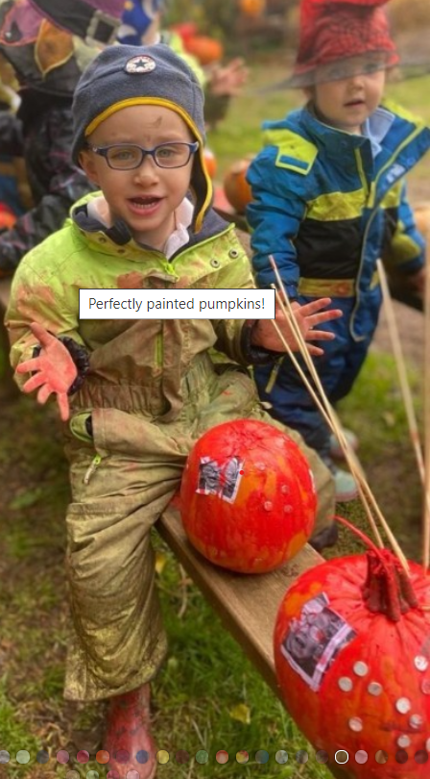
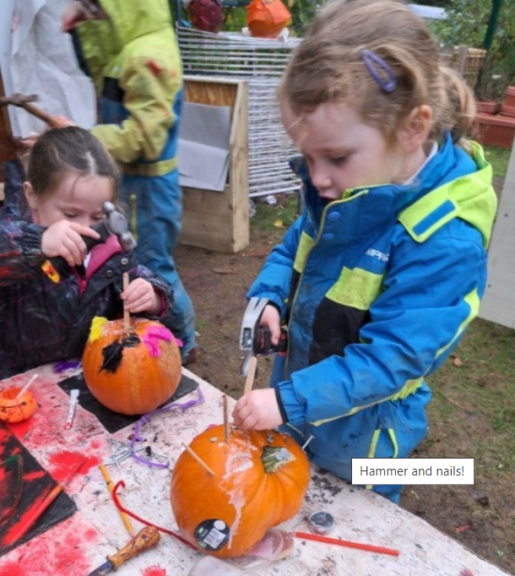
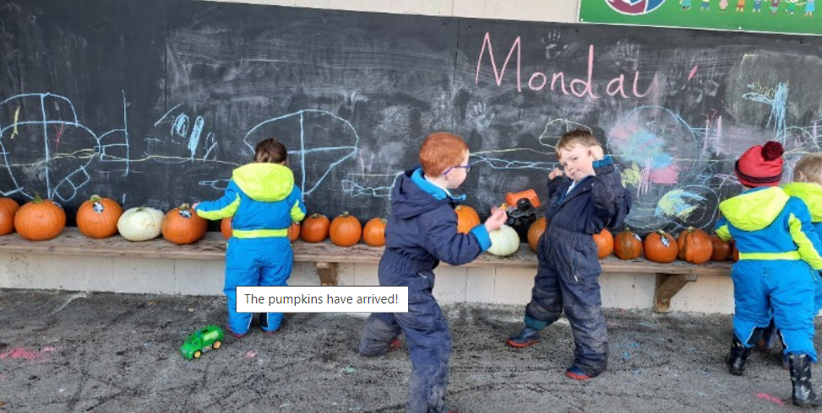
The children were encouraged to count the pumpkins and order them in size.
The pumpkins are the highlight of the first term. While we bring them onsite, we discuss how the seeds inside the pumpkin will grow into pumpkins. The forest school / outdoor environment lends itself to truly exploring the pumpkins. Having the time and space to exploit all the learning associated means that the process is holistic. While there is an adult directed activity i.e. decorate the pumpkins, the children have autonomy to be independently creative, using real tools such as hammer and nails.

