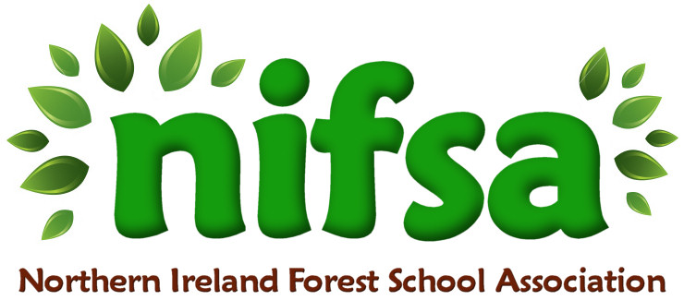

**NIFSA Lesson Plan Template**

|  |  |
| --- | --- |
| **Planning** | |
| **Location** | **Kilcooley primary school garden** |
| **Date** | **18/1/24** |
| **Class** | **3** |
| **Classroom Management** | Teacher and two classroom assistants.  Children will work in groups |
| **Connected Learning/Prior Knowledge** | Children have been learning about cold lands.  Science lesson – what happens to water when it is icy outside. |
| **Health and Safety** | **First aid kit with us, class list and parent contact numbers. Ratio met.** |
| **Learning Intention** | Class will identify what happens to water in winter. |
| **Success Criteria** | **To understand what happens to water in different temperatures.** |
| **Resources** | **Paper plates, objects from nature, string.** |
| **Differentiation/Target Groups** | CA will work with LA |
| **Other** |  |

|  |  |
| --- | --- |
| **Lesson Content** | |
| On Arrival | We will talk about the weather, how does it feel?  What season are we in?  What do you think will happen to water if it is this cold? |
| Activity explained | Children will collect items to put on their plate from the garden.  They will put water on them and add their string to the top.  We will leave these overnight. |
| Finishing | In the morning the children will go and see what happened to their water. They will create a ice decoration and hang it on the tree. We will check on it again when the weather changes. Is it still ice or has it melted.  Ask the children why. |

|  |  |
| --- | --- |
| **Evaluation/Review** | |
| How did the group session go? | The children responded well to this lesson and understood what would happen to the water.  They all participated and enjoyed the lesson. |
| Focus on individual pupils | Mason – enjoyed checking on the ice/water.  Tyler – able to identify what happens to the water in winter.  James – able to identify the season. |
| What would you change for next time? | The lesson worked well, I would use plastic plates as the ice stuck to the paper. |