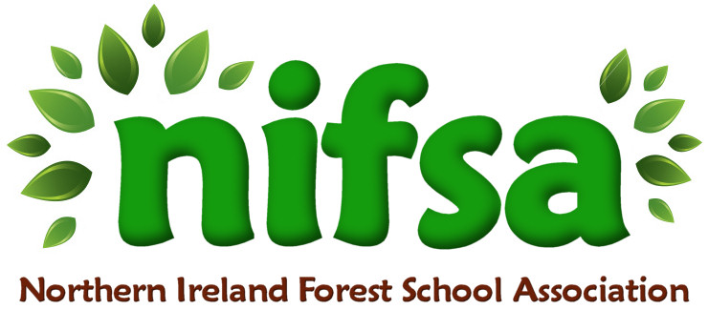

**NIFSA Lesson Plan Template**

|  |  |
| --- | --- |
| **Planning** | |
| **Location** | **Kilcooley Woods** |
| **Date** | **11/04/24** |
| **Class** | **3** |
| **Classroom Management** | Teacher and two classroom assistants.  Children will work in groups  3 classes going together so there will be additional teachers and CAs |
| **Connected Learning/Prior Knowledge** | Fractions |
| **Health and Safety** | **First aid kit with us, class list and parent contact numbers. Ratio met.** |
| **Learning Intention** | To use nature to show fractions |
| **Success Criteria** | **Children will show fractions, halves, quarters and thirds.** |
| **Resources** | **N/A** |
| **Differentiation/Target Groups** | CA With lower ability group to encourage them. |
| **Other** |  |

|  |  |
| --- | --- |
| **Lesson Content** | |
| On Arrival | Remind children of previous learning on Fractions. Get them to gather items that they can use to show fractions. |
| Activity explained | I will gather sticks to show the children what I expect them to do.  Showing one half using the sticks – how can I do this?  Can you show me one half ?  Repeat this for quarters and thirds. |
| Finishing | Talk to the children about what they have learned, can they identify, 1/2 , 1/4 , 2/4, 1/3. |

|  |  |
| --- | --- |
| **Evaluation/Review** | |
| How did the group session go? | The Children enjoyed the hands on numeracy lesson in nature. They were able to show fractions using nature items. The class were able to understand how to group the items. |
| Focus on individual pupils | Max – used stones and was able to identify fractions  Josie – understood how to show fractions using her items  Tyler – said he needed to use lots of similar items to make it an fair fraction. |
| What would you change for next time? | Do this activity in the garden and let the children use chalk. |