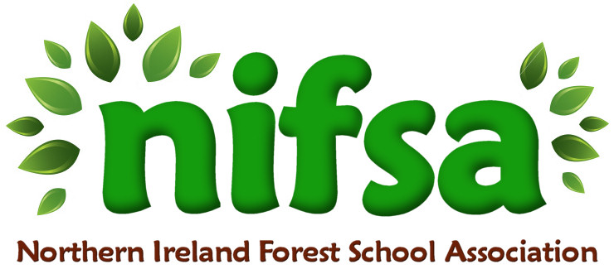

**NIFSA Lesson Plan**

Making Binoculars.

|  |  |
| --- | --- |
| **Planning** | |
| **Location** | **Glenbrook NS outdoor forest area** |
| **Date** | **23/02//24** |
| **Class** | **2** |
| **Classroom Management** | One adult leading the session (Mrs Shanks) for the introduction. The class then splits into 2 groups with one adult per group to lead the activity Additional adult as 1 to 1 support for an individual child. |
| **Connected Learning/Prior Knowledge** | Prior activity making bird feeders for the birds to help them find food in Winter. |
| **Health and Safety** | -Outside area checked for any potential hazards prior to session |
| **Learning Intention** | **Children will be able to explore the living creatures which visit our outdoor area.**  Children will have the opportunity to:  -learn independently and collaboratively (PSE)  -focus their attention and listen (L)  -understand simple rules. (PSE, M)  observe, explore, investigate and select materials and equipment in a range of situations (w)  -care for and respect living things (w)  -talk about their observations and make simple predictions (w)  -talk about Winter and explore seasonal changes through exploring and observing outside (W,L)  -demonstrate fine motor skills through drawing, collecting natural materials and making their binoculars (P)  -make choices and organise their own play (PSE)  -Share their learning at home through bringing binoculars home with them to enjoy in their own gardens while also leaving some in school. (W,PSE |
| **Success Criteria** | -Children are able to make their binoculars  -Children are able to identify natural materials and animals they can see in our environment using their binoculars. |
| **Resources** | Toilet roll tubes, string, scissors, glue, felt tips, whistle and boundary flags. |
| **Differentiation/Target Groups** | Support given to children as required.  1 to 1 support for a child with a Statement of Special Needs |
| **Other** |  |

|  |  |
| --- | --- |
| **Lesson Content** | |
| On Arrival | * Recap over forest school rules * Placing of boundary flags around perimeter * Discussions about previous activity, making bird feeders. Discussion about animals and living things we might see in our forest area. |
| Activity explained | * Demonstration of making binoculars as a whole group. * Children then split into 2 groups with one adult at each area. * Children to collect natural materials from the forest floor to use to decorate their binoculars. * Children can draw or stick onto their binoculars. * Children then use their binoculars to go on a hunt around the garden for natural materials and living things. |
| Finishing | * Re-cap over learning intentions. * Collection of boundary flags from perimeter. * Evaluation of session using visual cards. * Children then placed their binoculars into their trays to take home. Photos shared with Parents through Seesaw and families. |

|  |  |
| --- | --- |
| **Evaluation/Review** | |
| How did the group session go? | The group session went really well. All children were very excited to take part in our second session. The children loved using their binoculars and took them home. Some Parents sent in photos of them using them at home in the gardens. All children listened well to the instructions. |
| Focus on individual pupils | One child who does not enjoy art activities in class did not enjoy decorating the binoculars and was hard to motivate. |
| What would you change for next time? | Next time we would not encourage the children to stick on sticks to decorate their binoculars as they became frustrated when they fell off and lost interest. |