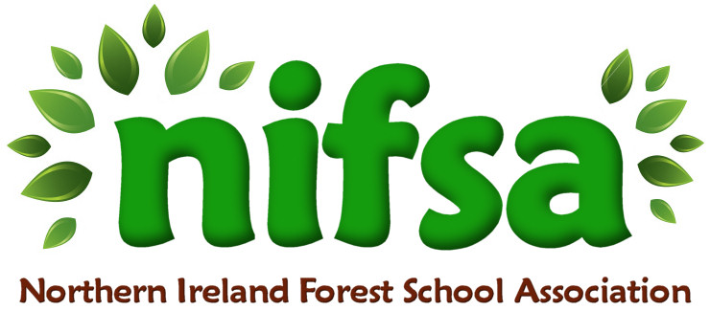

**NIFSA Lesson Plan**

Natural Counting Activities

|  |  |
| --- | --- |
| **Planning** | |
| **Location** | **Glenbrook NS outdoor forest area** |
| **Date** | **01/03/24** |
| **Class** | **2** |
| **Classroom Management** | 2 smaller groups, activity repeated with the second group. Both sessions were led by Mrs Shanks. |
| **Connected Learning/Prior Knowledge** | Children have been exploring counting naturally in their play. We have recently added more natural materials in our loose part area in class. |
| **Health and Safety** | -Outside area checked for any potential hazards prior to session  -Children will wash hands afterwards |
| **Learning Intention** | **Children will explore counting with natural materials outside.**  Children will have the opportunity to:  -learn independently and collaboratively (PSE)  -focus their attention and listen (L)  -understand simple rules. (PSE, M)  observe, explore, investigate and select materials and equipment in a range of situations (w)  -care for and respect living things (w)  -talk about their observations and make simple predictions (w)  -make choices and organise their own play (PSE)  -continue to explore early maths through counting objects and exploring numbers (m)  -collect materials that are similar/different and discuss their properties (w,m) |
| **Success Criteria** | -Children are able to work together to collect a variety of natural materials  -Children explore counting and 1 to 1 correspondence through counting out objects during the activities |
| **Resources** | -Baskets, lollipop sticks, natural materials, number cards, whistle and boundary flags. |
| **Differentiation/Target Groups** | Support given to children as required.  1 to 1 Assistance for child with SEN. |
| **Other** |  |

|  |  |
| --- | --- |
| **Lesson Content** | |
| On Arrival | * Recap over forest school rules * Placing of boundary flags around perimeter |
| Activity explained | * Discussion around plans for the session. * Children to find a friend and collect natural materials from the forest floor with their partner. * Children to bring their natural materials back and make their shapes/ numbers as Mrs Shanks explains. * Children to place 1 /2/3 items into their squares as explained. |
| Finishing | * Re-cap over learning intentions. * Children to showcase their work. * Children to put all of their natural materials back on the forest floor again. * Collect the boundary flags. |

|  |  |
| --- | --- |
| **Evaluation/Review** | |
| How did the group session go? | The session was great. The children enjoyed going round the forest in their pairs to collect the natural materials. When I blew the whistle for the children to stop and then two times for them to return, all children were able to follow the instruction. It was quite a windy day that day and it was quite hard for the natural materials to stay in the square that the children had made. |
| Focus on individual pupils | A few children got cross at the wind blowing their natural items away. They needed some support to return to the activity. |
| What would you change for next time? | Instead of using lollipop sticks as their ‘activity boundary’ to place their items in, I would give the children a plate or individual tray to keep their items in place. This would make it easier for them to count with and would reduce any frustration. |