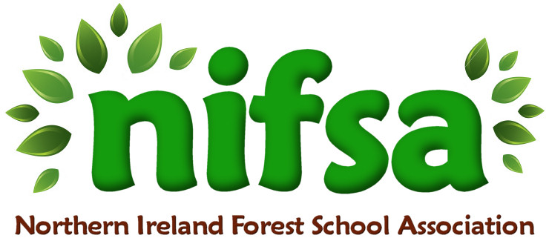

**NIFSA Lesson Plan**

Imaginative play- making a campfire.

|  |  |
| --- | --- |
| **Planning** | |
| **Location** | **Glenbrook NS outdoor forest area** |
| **Date** | **29/02/24** |
| **Class** | **2** |
| **Classroom Management** | -Whole class splits into 2 smaller groups |
| **Connected Learning/Prior Knowledge** | The children had been talking about going camping and building a campfire in the forest. |
| **Health and Safety** | -Outside area checked for any potential hazards prior to session |
| **Learning Intention** | **Children will engage in imaginative play around going camping and making a campfire.** (A,L,PSE)  Children will have the opportunity to:  -learn independently and collaboratively (PSE)  -focus their attention and listen (L)  -understand simple rules. (PSE, M)  observe, explore, investigate and select materials and equipment in a range of situations (w)  -care for and respect living things (w)  -talk about their observations and make simple predictions (w)  -talk about weather and explore seasonal changes through exploring and observing outside (W,L)  -make choices and organise their own play (PSE) |
| **Success Criteria** | -Children have fun engaging in imaginative play around going camping and making a campfire. |
| **Resources** | -Children collect sticks, stones, leaves etc.  -Whistle and boundary flags. |
| **Differentiation/Target Groups** | Support given to children as required. |
| **Other** |  |

|  |  |
| --- | --- |
| **Lesson Content** | |
| On Arrival | * Recap over forest school rules * Placing of boundary flags around perimeter |
| Activity explained | * Children led in imaginative session around helping to make a campfire and going on a camping trip. |
| Finishing | * Re-cap over learning intentions. * Collection of boundary flags and ensuring we leave no trace. |

|  |  |
| --- | --- |
| **Evaluation/Review** | |
| How did the group session go? | The small group of children that took part really enjoyed making an imaginary fire with hot chocolate. We collected the sticks and leaves to build the fire and we also collected stones to surround the ‘fire’ area. Each child then got a cup and we all pretended to heat the hot chocolate over the fire. We talked about the fire making the chocolate hot and the children shared their own experiences of camping and being at a campfire. |
| Focus on individual pupils | One child enjoyed being the host and loved serving the drinks to her friends. One child was able to show us how he had built a fire when camping with his Grandpa. We discussed safety issues and talked about staying safe around fire. A few of the children continue to replicate this play when outside and they love imaginary play around camping. |
| What would you change for next time? | I think we will develop this in making a real fire with real hot chocolate on a cold day. |