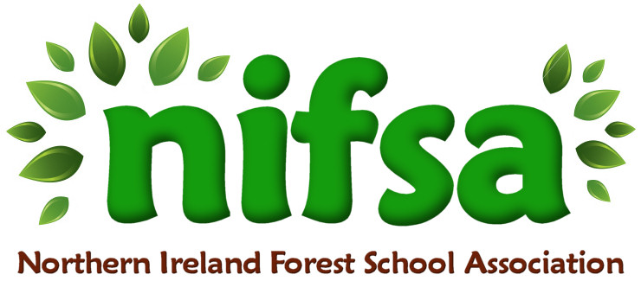

**NIFSA Lesson Plan**

Mud Painting – Wellie boot printing.

|  |  |
| --- | --- |
| **Planning** | |
| **Location** | **Glenbrook NS outdoor forest area** |
| **Date** | **26/04/24** |
| **Class** | **2** |
| **Classroom Management** | -Whole class splits into 2 smaller groups  -Wellie boot prints |
| **Connected Learning/Prior Knowledge** | We had lots of muddy puddles due to the very wet weather outside. We wanted to explore the mud in a different way. |
| **Health and Safety** | -Outside area checked for any potential hazards prior to session |
| **Learning Intention** | **Children will learn about their environment and use natural material to create.**  Children will have the opportunity to:  -learn independently and collaboratively (PSE)  -focus their attention and listen (L)  -understand simple rules. (PSE, M)  observe, explore, investigate and select materials and equipment in a range of situations (w)  -care for and respect living things (w)  -talk about their observations and make simple predictions (w)  -talk about weather and explore seasonal changes through exploring and observing outside (W,L)  -make choices and organise their own play (PSE)  -Create using the mud and natural materials |
| **Success Criteria** | -Children have fun exploring the mud  -Children can create their own art using the mud and their own creative ideas |
| **Resources** | -Mud  -Wellie boots  -Paper  -Boundary flags and whistle |
| **Differentiation/Target Groups** | Support given to children as required. |
| **Other** |  |

|  |  |
| --- | --- |
| **Lesson Content** | |
| On Arrival | * Recap over forest school rules * Placing of boundary flags around perimeter |
| Activity explained | * Discussion on the activity and demonstration. * Children spilt into 2 groups- one with each adult, completing the same activity. |
| Finishing | * Re-cap over learning intentions. * Children can showcase their art work. * Collection of boundary flags and ensuring we leave no trace. |

|  |  |
| --- | --- |
| **Evaluation/Review** | |
| How did the group session go? | This session was fantastic! The children loved jumping in the mud and got really messy. They enjoyed seeing their footprints and they loved talking about the size and differences in their wellie boot prints. Some children fell in the mud and got really messy and it was great that we had our outdoor suits on. We recorded a video of this to send home and the Parents loved seeing them singing and jumping in the mud! |
| Focus on individual pupils | One child who doesn’t like getting dirty actually enjoyed this activity once they saw their friends joining in. This is great progress for this child and was great to see. One child talked about the Bear Hunt story and we were able to talk about the squelchy mud. This resulted in us retelling the story as we played. |
| What would you change for next time? | I gave each child an A4 page each. Next time I will use a large roll of paper so the children can see their prints change as they walk, run, jump and this will extend this activity for them. |